Trust-the-Bucc
Description | My friend works at Buc-ee's now as their mascot. We were road-tripping and stopped at a gas station, which he then claims was the first Buc-ee's location he worked at.... but then why isn't it still a Buc-ee's? He couldn't answer so I'm having a hard time believing him. Here's a picture of the building. Can you tell me the store number of this Buc-ee's location... if it even was one.
Files | storefront.jpg — one photograph. Submit RCC{number}.  Photograph: Mike / Houston Historic Retail.
Hint(s) | 1. A new sign does not necessarily mean a new building. Some smaller Buc-ee's locations continued operating under other brands.  2. The taco sign is useful. Look for accounts of former Buc-ee's stores converted to Stripes, and compare the storefront.  3. Historical fuel-network directories can preserve a former operator's store number. Match the street address on the same row.
Walkthrough | 1. Search for former Buc-ee's locations converted to Stripes. Mike's Houston Historic Retail visit contains the supplied photograph in its El Campo gallery. Match the taco sign, stone wall, canopy and ice machines. The preceding paragraph identifies 2403 N. Mechanic Street, El Campo, Texas; the later Eagle Lake gallery is a different store.  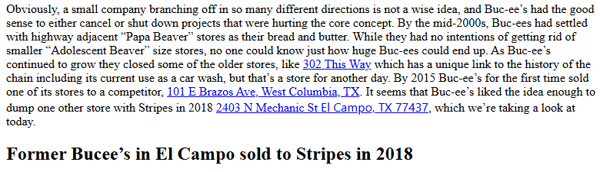  2. Search the address with Buc-ee's to find the historical fuel-location directory. Open PDF page 147 and locate 2403 N Mechanic.  3. Read the same row: Buc-Ee's #27, El Campo, TX 77437. The requested former store number is 27.  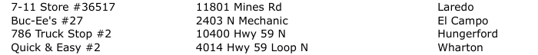
Flag | RCC{27}

